Physics TDC Sample Exam Two
Written Paper 2BPHY
Question/Answer Booklet

Student Number: In figures

In words

Student name: ______ANSWER KEY__________ Teacher name: _________________

Time allowed for this paper
Reading time before commencing work: Ten minutes
Working time for paper: Two hours 30 minutes

Material required/recommended for this paper

To be provided by the supervisor
This Question/answer booklet; Formulae and constants sheet

To be provided by the candidate
Standard items: pens, pencils, eraser or correction fluid, ruler, highlighter

Special items: scientific non-programmable calculator

Important note to candidates
No other items may be taken into the examination room. It is your responsibility to ensure that you do not have any unauthorised notes or other items of a non-personal nature in the examination room. If you have any unauthorised material with you, hand it to the supervisor before reading any further.

All calculations are to be set out in detail. Marks may be awarded for correct equations and clear setting out, even if you cannot complete the calculation. Express numerical answers to two (2) or three (3) significant figures and include units where appropriate.

Student Marks
Section |  | Percentage of paper | Maximum mark | Student Mark
Section One  15 - 20 questions | Short Answer  35-45% | 40 | 40
Section Two  4 – 7 questions | Problem Solving  45-55% | 50 | 50
Section Three  1 -2 questions | Comprehension  5-15% | 10 | 10
Student Percentage
Structure of this paper

Section of exam | Suggested working time | Number of questions | Number of questions to be attempted | Marks available
Section One | 60 minutes | 14 | all | 40
Section Two | 75 minutes | 4 | all | 50
Section Three | 15 minutes | 1 | all | 10
Total marks |  |  |  | 100

Instructions to candidates

- The rules for the conduct of Western Australian external examinations are detailed in the Year 12 Information Handbook 2010. Sitting this examination implies that you agree to abide by these rules.

- Write your answers in this Question/Answer Booklet.

- A blue or black ballpoint or ink pen should be used except for graphs were a pencil should be used.

- Working or reasoning should be clearly shown when calculating answers and answers should be given to three (3) significant figures were appropriate.

- You must be careful to confine your responses to the specific questions asked and to follow any instructions that are specific to a particular question.

- Spare pages are included at the end of this booklet. They can be used for planning your responses and/or as additional space if required to continue an answer.
  - Planning: If you use the spare pages for planning, indicate this clearly at the top of the page.
  - Continuing an answer: If you need to use the space to continue an answer, indicate in the original answer space where the answer is continued, i.e. give the page number. Fill in the number of the question(s) that you are continuing to answer at the top of the page.

Section one: Short answer 40 marks

This section has fourteen (14) questions. Answer in the spaces provided.

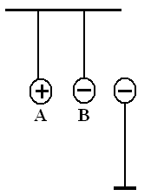
- Three charged spheres are placed near each other and held. Spheres A and B are free to move but sphere C is in a fixed position. Once released, describe the initial motion of A and B. (2 marks)

The negatived will move right towards the positive [1 mark]
The positive will move towards the negative and probably touch
[1 mark]

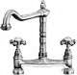
- A single outlet connected to both taps over a kitchen sink is supplied with cold water at 8.0⁰C and hot water at 64⁰C. Two students are measuring the flow and finds out that the cold water tap is giving a flow of 8.0 litre min⁻¹. They then adjust the hot water tap to give a total flow rate of 14.0 litre min⁻¹ through the outlet. One student then measured the temperature of the warm water. What was this temperature?
(2 marks)
Mass hot water = 14 – 8 = 6 litres min⁻¹

mcΔT (hot water) = mcΔT (cold water)
as specific heat, c, is constant
8(T_{f} – 8) = 6(64 – T_{f}) [1 mark]
8T_{f} – 64 = 384 – 6T_{f}
8T_{f} + 6T_{f} = 384 + 64
14T_{f} = 448
T_{f} = 32 ⁰C [1 mark]

- Water is the main liquid used in car cooling systems. Explain, in terms of physics principles, why water is used. (3 marks)

Water has a high specific heat [1 mark]
Water can easily flows around cooling system [1 mark]
Water can absorb a large amount of energy before increasing temperature [1 mark]

- A child’s toy robot requires 4.50 V to run. The batteries supply a current of 3.00 x 10² mA and a power output of 1.35 W. Calculate the electrical resistance of the robot. (2 marks)

I = 0.300 A P = I²R
1.35 = (0.30)² x R [1 mark]
R = 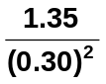
R = 15.1 Ω [1 mark]

- Two students are studying for their Physics Examination. How much energy would a kettle needed to supply in order to heat 565 mL of water initially at 18⁰ C to 90⁰ C to make the students a cup the tea? (2 marks)

Q = mcΔT
= 0.565 x 4180 x (90 – 18) [1 mark]
= 170042.5
Q = 1.70 x 10⁵ J [1 mark]

- A research assistant was trying to determine the latent heat of fusion of a new material. He recorded both the energy added and the temperature of the material. The graph below shows his results.
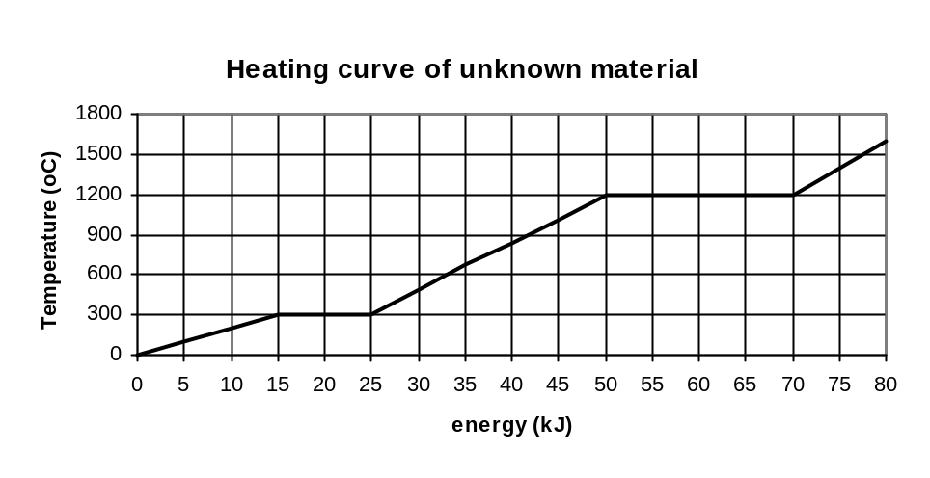
He determined that the latent heat of fusion for this material was 2.00 x 10⁵ J kg⁻¹. What mass of material was he using? (2 marks)

Q for latent heat = 10 kJ [1 mark] Q = mL
10 000 = m x 2.00 x 10⁵
m = 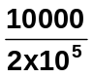
m = 0.0500 kg [1 mark]

- a. The diagram on the right shows a form of heat transfer. Name this form of heat transfer, and explain the physics about how it occurs. (3 marks)

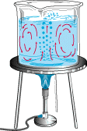
Convection and occurs in fluids (gases and liquids) [1 mark]

Heat energy increases E_{k} of molecules [1 mark]

Particles move faster and further apart so become less dense and rise up
When cooled, less E_{k} so becomes more dense and sinks [1 mark]

- Name a natural phenomena that is a result of this form of heat transfer. (1 mark)
Convection currents or any other appropriate phenomena [1 mark]

- An electrical circuit on 24.0 V and a current of 200 mA is run for 4.0 minutes. How much work was done during this time? (2 marks)

W = VIt W = VIt
= 24 x 0.2 x 240 [1 mark]
t = 4 x 60 = 1152 J
= 240 s
V = 24 W = 1.15 x 10³ J [1 mark]
I = 0.2 A

- Tom was given four 3.00 Ω resistors. Draw a diagram below to show how he could connect the four resistors to give a total resistance of 4.00 Ω. (2 marks)

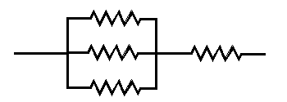

- Ice making and dispensing machines are part of some expensive fridges. In one particular fridge, 1.50 kg of water enters the insulated compartment at 15.0 ⁰C and needs to be cooled to produce ice cubes which are at -5.00 ⁰C.
  - How much energy does the fridge remove from the water for this to occur? (3 marks)

Q = (1.5 x 4180 x 15) + (1.5 x 3.34 x 10⁵) + (1.5 x 2100 x 5] [2 marks]

Q = 94050 + 501000 + 15750

Q = 610800

Q = 6.11 x 10⁵ J [1 mark]

  - The fridge is connected to the 2.40 x 10² V power supply and receives 2.00 A of current. How long will the ice cubes take to make? (If you couldn’t obtain an answer from part (a) then use 6.00 x 10⁵ J) (2 marks)

Q = VIt
610800 = 240 x 2 x t [1 mark]
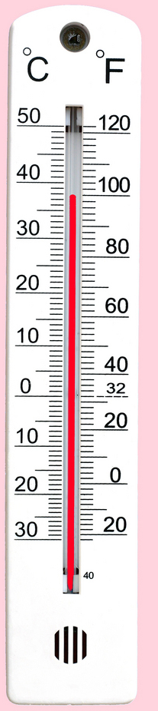
t = 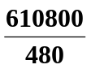
t = 1272.5

t = 1.27 x 10³ s [1 mark]

If use 6.00 x 10⁵ J then 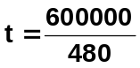
t = 1.88 x 10³ s

- The weather thermometer on the right is used to show the temperature in degrees Celsius and Fahrenheit.

a. What is the reading in degrees Celsius on the thermometer?
38 ⁰C [1 mark]
b. What is the absolute error of the reading?
±0.5 ⁰C [1 mark]
- Within the oval area, where could a charged particle P be placed so that it experiences no net force? You will need to draw in the field lines to justify your placement. (4 marks)
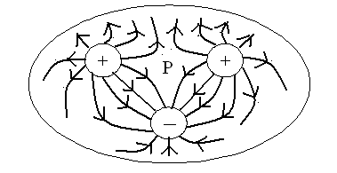

1 mark for arrows
1 mark for P
2 marks for diagram

- Sam has set up an unusual experiment in static electricity to investigation charged particles. A small sphere is suspended 1.50 cm above another sphere in a frictionless pipe. The bottom sphere has a charge of +15.0 nC, and both have a mass of 0.300 g. Calculate the charge on the top sphere? (Hint: Consider all forces acting not just the electrical forces.) (4 marks)

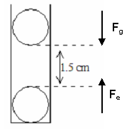
F_{g} = F_{e}
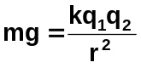 [1 marks]
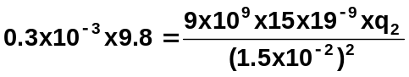 [2 mark]
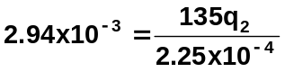

135q₂ = 2.94 x 10⁻³ x 2.25 x 10⁻⁴
= 6.615 x 10⁻⁷

q₂ = +4.9 x 10⁻⁹ C [1 marks]

(4.9 nC)

- In another situations, Jeremy has set up two freely hanging charged spheres which have a charge of +10.0 nC and -6.00 nC respectively. Jeremy brings the spheres together to touch each other and then releases them. Once released the particles settle 8.00 cm apart from each other. Calculate the force they exert on each other at this time? Show all working. (4 marks)

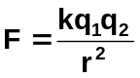+10 -6

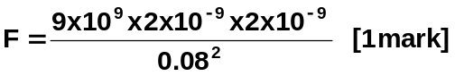
+10-6 = +4

+2nC +2nC F = 5.63 x 10⁻⁶ N repulsion
[1 mark] [1 mark]

[1 marks]

Section two: Problem-solving 50 marks

This section has four (4) questions. Answer in the spaces provided.

- 1. [12 Marks]

A university student was heating a 9.45 kg sample of a solid material in an insulated container which had an electrical heating coil which supplied heat at a rate of 365 W.

He measured the temperature of the substance every minute and the graph below shows the change in temperature over a 12.0 minute period.
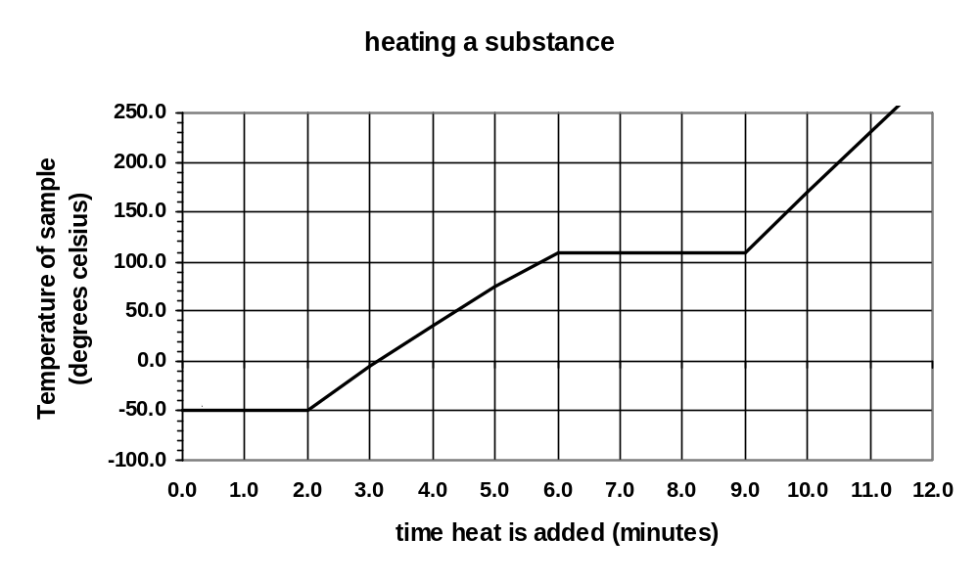
a. What is the melting temperature of the solid? (1 mark)

-50 ⁰C [1 mark]

b. What phase(s) is/are present between points C and D on the graph? (1 mark)

liquid and gas [1 mark]

- d. How much heat energy was absorbed while the liquid was evaporating? (2 marks)

t = 3 x 60 E = Q = Pt
= 180 s = 365 x 180 [1 mark]
energy = 65700
= 6.57 x 10⁴ J [1 mark]

e. Calculate the latent heat of evaporation for the substance. (2 marks)

Q = mL
65700 = 9.45 x L [1 mark]

L = 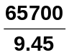
L = 6952

L = 6.95 x 10³ J kg⁻¹ [1 mark]

- f. Which is greater, the specific heat of the liquid or that of the gas? Explain without using a
- calculation (2 marks)

Liquid, [1 mark]

Gradient of graph is less so more energy is absorbed before change in temp. [1 mark

g. Calculate the specific heat for the substance in the liquid phase. (4 marks)

t = 4 x 60 Q = mcΔT
= 240 s 87600 = 9.45 x c x 160 [1 mark]
[1 mark] c = 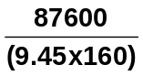
ΔT = 110 – (-50)
= 160 ⁰C c = 57.9 J kg⁻¹ K⁻¹ [1 mark]

Q = Pt
= 365 x 240
= 87600 J

[1 mark]

2. [15 marks]

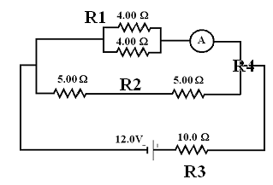
Two students have set up a circuit for an investigation. The circuit diagram to the right shows a battery connected to a number of resistors.

- Calculate the total circuit resistance.
(3 marks)

R1 = (4⁻¹ + 4⁻¹)
= 2 Ω

R2 = 5 + 5 = 10 Ω [1 mark]

R4 = (2⁻¹ + 10⁻¹)
= 1.6667 Ω [1 mark]

R(total) = 10 + 1.6667
R_{T} = 11.7 Ω [1 mark]

- Calculate the total current through the circuit. (2 marks)

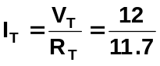 [1 mark]
I_{T} = 1.0286 A [1 mark]

- Calculate the potential difference across the 10.0 Ω resistor. (2 marks)

R₃ = 10 Ω V = IR
I_{T} = 1.0286 A = 1.0286 x 10 [1 mark]
V_{10Ω} = 10.286 V [1 mark]

- Calculate the potential difference across one of the 5.00 Ω resistors. (2 marks)

V across both 5Ω resistors = 12.0 – 10.286
= 1.714 V [1 mark]

As each resistor has half the potential difference,

V for one 5Ω resistor = 1.714 ÷ 2
= 0.857 V [1 mark]

- What is the reading on the ammeter? (3 marks)

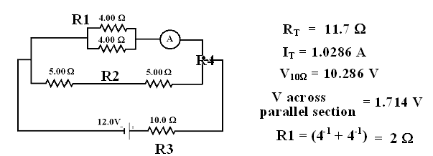

From the above data

R (4 Ω parallel section) = 2.0 Ω
V (4 Ω parallel section) = 1.714 V [1 mark]

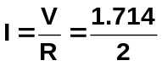 [1 mark]

I = 0.857 A

So ammeter = 0.857 A [1 mark]

- If the 4.00 Ω resistors were connected in series rather than in parallel, would the reading on the ammeter increase, decrease or stay the same? Without any calculations, explain your answer.
(3 marks)

DECREASE [1 mark]
Current is inversely proportional to resistance therefore increase resistance and current decreases. [1 mark]
When 4.0 Ω resistor put in series total resistance goes from 2.0 Ω to 8.0 Ω, as resistance has increased, current has decreased so metre reads less. [1 mark]

3. [14 marks]
The resistance is the measure of how much ‘friction’ a conductor presents to an electric current. Consider the factors that affect resistance:
- Length (l). It is found that resistance increases proportionately with the length of a conductor
e.g. R ∝ l
- Cross-sectional area (A). The greater the cross-sectional area of a conductor, the smaller its resistance. e.g. R ∝ 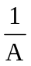
- Resistivity of the material (ρ - pronounced ‘rho’). An electrical property of materials is their resistivity. The resistance of a conductor is proportional to its resistivity; e.g. R ∝ ρ

These relationships can be combined as follows:

R = ρ l where R = resistance in ohms (Ω)
A ρ = resistivity in ohm metres (Ωm)
l = length in metres (m)
A = cross-sectional area in square metres (m²)

A group of students were investigating the change in resistance of a metallic wire with a cross-sectional area of 1.257 x 10⁻⁷ m² against the length of wire used. They set up a circuit with a constant 12.0 V and measured the current in 0.25 m of the wire. They then increased the length of the wire from 25 cm to 100 cm in 25 cm increments and again measured the current.

- For this investigation name the:
  - independent variable. Length of wire (1 mark)
  - dependent variable. Current (1 mark)
  - two control variables. Same PD, same diameter of wire, same material, etc (2 marks)
- Write an appropriate hypothesis for this experiment. (2 marks)

As the length of the wire is increased then the current of the wire decreases.
[1 mark answer with no ratio]

As the length of the wire is increased doubled, then the current of the wire decreases by half.
[2 mark answer with ratio]

- The data they collected is shown below. Complete column three of the table to show the resistance of the wire at various lengths. (2 marks)

Length (m) | Current (A) | Calculated resistance (Ω)
0.25 | 0.060 | R = 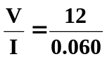 = 200
0.50 | 0.030 | 400
0.75 | 0.020 | 600
1.00 | 0.015 | 800

- Calculate the resistivity of the first line of data, show your working below. (2 marks)

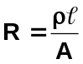
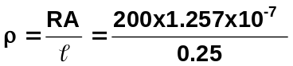 [1 mark]
= 1.0056 x 10⁻⁴ Ωm [1 mark]

- If the radius of the wire was doubled, the value of the resistance would
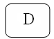
    - double
    - say the same
    - halve
    - quarter answer (1 marks)

- If the resistance of the wire was doubled, the value of the resistivity would

    - double
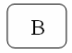
    - say the same
    - halve
    - quarter answer (1 marks)

g. if the length of the wire was halved, the value of the resistance would

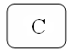
- double
- say the same
- halve
- quarter answer (1 marks)

4. [9 marks]
An electrical circuit is set up by a teacher to test students understanding of current, resistance and potential difference. The meters used in the circuit do not have any influence on the circuit other than to register current and potential difference. The students could see the readings on five of the meters but the teacher had covered the dials of three of the meters so the students could not see what they registered. A diagram of the circuit is below.

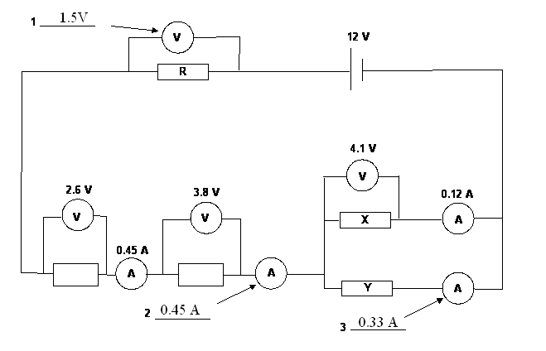

a. Calculate what the readings on the three meters would be, and write the values next to the meters
in the spaces provided. (3 marks)

V = 12 – (2.6 + 3.8 + 4.1) = 1.5 V [1 mark]

A = 0.45 A [1 mark]

A = 0.45 – 0.12 = 0.33 A [1 mark]

b. Calculate the resistance of X. (2 marks)

V = I.R
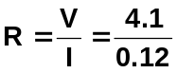 [1 mark]
R = 34.2 Ω [1 mark]

c. Calculate the quantity of charge which flows through resistance Y in 5.0 min. (2 marks)

q = I t
= 0.33 x 5 x 60 [1 mark]
= 99 C [1 mark]

d. Calculate the value of resistance R. (2 marks)

V = I R
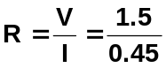 [1 mark]
R = 3.33 Ω [1 mark]

Section three: Comprehension 10 marks
This section has one (1) question. Answer in the spaces provided.

QUESTION ONE:60

Recollections of my Grandmother
I remember many pleasant Sunday mornings sitting with my Grandmother as she told me stories of her life which was very different to mine. She loved to talk about when she was a young girl and learnt that her family was to move to the ‘big city’. Hers was a large family and some of the younger children, herself included, had never been to Melbourne. She remembered being very excited about it.

There was such excitement when she arrived at her new home in Melbourne as it was equipped with electricity for lighting and gas for cooking, heating, so very modern and so very different from her country home. Some of the surrounding homes were still lit by gas mantels, gas stoves replaced the wood-fuelled ones (which had made kitchens so hot in summer) and small gas-heated water cisterns appeared on kitchen walls to service the sink. Washing was speeded up in gas-heated coppers and gas fires replaced the cheerful (but yet wasteful) wood fires in open fireplaces. Electricity was gradually appearing on the scene, but until probably well into the 1920s the normal suburban household was equipped with only one power point – usually for the electric iron. The socket had two holes only (no earth). She remembered when she first moved into their new house, her mother proudly showing her where the wonderful new electric iron was to be connected, by touching the socket with two of her fingers. Unfortunately she gave herself a nasty electric shock which gave everyone a good laugh later. With the current safety devices installed in our homes today, that is less likely to happen now.

She remembered that then there were no vacuum cleaners, electric blenders and other appliances we take for granted today, and she was the dish washer! The first electrical kitchen aids were the electric iron and toaster, and a small one-bar radiator for winter. With only one electrical outlet, double adapters boomed. Fitted into the central hanging light socket, one could connect a radiator or toaster, as long as the old fuses didn’t blow! With the advent of other electrical implements, electricians must have reaped a small fortune rewiring houses and installing power points in every room. It was certainly different then.

- Up until the 1920s, most homes only had one power point. What was this usually used for?
Electric iron [1 mark]
- Early electrical homes had no earth wire. What is the purpose of an earth wire? (1 marks)

The earth wire is designed to carry away excess current from appliances in such cases as short circuits and to prevent current flowing through people.
[1 mark]

- Many appliances today such as hairdryers don’t have an earth connection. Explain how are these appliances are made safe? (2 marks)

Double insulation. [1 mark]
Not only are all internal conductors insulated with plastic, but appliance is also covered in plastic insulation – two layers of plastic so double insulation. [1 mark]

- Name one electrical safety devise in the home and explain how it works. (2 marks)

Any suitable answer but probably fuse or circuit breakers.
FUSE:
Excess current causes wire to melt so circuit breaks and no current to cause damage. Wire must be replaced with similar type of fuse wire.

OR

CIRCUIT BREAKER:
Excess current causes electromagnetic switch to turn off and so breaks the circuit. No circuit so no current to cause damage. Need to push switch back on once problem fixed.

- Modern homes have many power points and light switches. Often, one light can be controlled by two switches.

In the diagram below, is the light from the two-way switch on or off? ___OFF______ (1 mark)
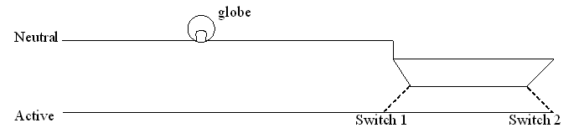
- Light globes are non-ohmic resistors. Explain what this means. Include diagrams to help your explanation. (3 marks)

In non-ohmic resistors, the potential difference is not proportional to the current. Often, as the potential difference is increased so does the temperature of the resistor and the resistance increases. [1 mark]

Ohmic resistors maintain a constant resistance over all ranges of potential difference and currents and heating doesn’t affect their resistance. [1 mark]

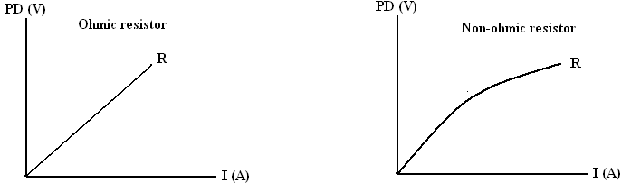
[1 mark]

End of Examination

This page is available for any working required.
________________________________________________________________________________________________________________________________________________________________________________________________________________________________________________________________________________________________________________________________________________________________________________________________________________________________________________________________________________________________________________________________________________________________________________________________________________________________________________________________________________
________________________________________________________________________________________________________________________________________________________________________________________________________________________________________________________________________________________________________________________________________________________________________________________________________________________________________________________________________________________________________________________________________________________________________________________________________________________________________________________________________________
________________________________________________________________________________________________________________________________________________________________________________________________________________________________________________________________________________________________________________________________________________________________________________________________________________________________________________________________________________________________________________________________________________________________________________________________________________________________________________________________________________
__________________________________________________________________________________________________________________________________________________________________________________________________________________________________________________________________________________________________________________________________________________________________________________________________________________________
This page is available for any working required.
________________________________________________________________________________________________________________________________________________________________________________________________________________________________________________________________________________________________________________________________________________________________________________________________________________________________________________________________________________________________________________________________________________________________________________________________________________________________________________________________________________
________________________________________________________________________________________________________________________________________________________________________________________________________________________________________________________________________________________________________________________________________________________________________________________________________________________________________________________________________________________________________________________________________________________________________________________________________________________________________________________________________________
________________________________________________________________________________________________________________________________________________________________________________________________________________________________________________________________________________________________________________________________________________________________________________________________________________________________________________________________________________________________________________________________________________________________________________________________________________________________________________________________________________
____________________________________________________________________________________________________________________________________________________________________________________________________________________________________________________________________________________________________________________________________________________________________________________________________________________________________

